***SGD LAB EXP – 3C***

**Name** : Aditi Chhajed; **Reg. No.** : 221081009

**Branch** : IT ; **Course Instructor** : Prof. Vedashree Awati

Name : Aditi Chhajed

Reg.No : 22108100

***Aim:***

*To create databases for my topic – Urban Panning and execute the given queries.*

***Theory:***

*Urban planning relies on a structured approach to manage land use, ensure organized development, and provide essential services to communities. This schema is designed to support urban planners by organizing key data in a way that allows for efficient analysis, monitoring, and decision-making. Each component—from roads and zones to buildings and public facilities—captures vital aspects of the city’s layout and usage, creating a comprehensive framework to maintain balanced growth and improve resource allocation.*

*The schema helps answer critical questions such as:*

* *How does the zoning distribution affect residential and commercial expansion?*
* *Are there enough public facilities in each area to meet population demands?*
* *Which zones are underutilized or overdeveloped?*
* ***Structure of the Schema***

*The schema is composed of five main tables:*

1. ***Zones****: Defines different areas of land usage (e.g., residential, commercial) with specific regulations and constraints. Each zone includes data on building height restrictions and spatial boundaries, which helps urban planners adhere to regulatory requirements and zoning laws.*
2. ***Buildings****: Contains details about individual buildings, such as their type, height, floor area, and spatial location. This table allows tracking of infrastructure within zones and compliance with zoning restrictions.*
3. ***Roads****: Represents the transportation network with information on road type, lane count, and length. This table is critical for analyzing accessibility, traffic flow, and proximity of buildings to major roads.*
4. ***Public Facilities****: Lists facilities such as schools, hospitals, parks, etc., along with their capacity and location. This table helps assess service coverage in different areas, which is essential for meeting community needs and reducing resource strain.*
5. ***Land Parcels****: Holds information on individual parcels of land, including ownership and usage type. This table enables management of land resources, parcel development, and real estate monitoring.*

* ***Relationships Between Entities***

*The schema is designed to reflect the real-world relationships between these entities, emphasizing spatial and regulatory connections.*

1. ***Zones to Buildings (One-to-Many)****:*
   1. *Each* ***Zone*** *can contain multiple* ***Buildings****. This relationship allows urban planners to monitor the number of buildings in each zone, ensuring zoning regulations are adhered to.*
   2. *This relationship also allows for analysis of infrastructure density and development patterns within each zone.*
2. ***Zones to Land Parcels (One-to-Many)****:*
   1. *Each* ***Zone*** *includes several* ***Land Parcels*** *used for various purposes (residential, commercial, etc.). This relationship helps track land use and ownership within zones, supporting zoning enforcement and land management.*
3. ***Zones to Public Facilities (One-to-Many)****:*
   1. *Each* ***Zone*** *may host several* ***Public Facilities*** *such as parks, hospitals, and schools. This relationship enables analysis of how well community needs are met in each zone and highlights gaps in essential services.*
4. ***Buildings to Roads (Many-to-One)****:*
   1. *Each* ***Building*** *may be close to a* ***Road****, but multiple buildings can be associated with the same road. This relationship allows analysis of building proximity to transportation routes, which is crucial for accessibility and emergency planning.*
5. ***Zones to Roads (Many-to-Many)*** *(optional):*
   1. *Multiple* ***Zones*** *may have shared access to a* ***Road****, and a road can span across multiple zones. This relationship aids in understanding connectivity between zones and the shared infrastructure across different parts of the city.*

* ***Use Cases:***

***1. Zoning Compliance***

* ***Objective****: Ensure buildings comply with height restrictions in specific zones.*
* ***Action****: Query Buildings by zone_id and compare heights to allowed_building_height in Zones.*
* ***Result****: Identify and manage regulation violations efficiently.*

***2. Facility Distribution Analysis***

* ***Objective****: Assess the adequacy of public facilities across zones.*
* ***Action****: Count facilities per zone from Public_Facilities and compare with population data.*
* ***Result****: Pinpoint underserved areas for targeted facility expansion.*

***3. Traffic Planning***

* ***Objective****: Analyze impact of commercial areas on traffic near major roads.*
* ***Action****: Identify buildings close to high lane_count roads from the Roads table.*
* ***Result****: Support data-driven decisions for road expansions or traffic control.*

***4. Land Use Optimization***

* ***Objective****: Track land parcels available for development.*
* ***Action****: Query Land_Parcels by usage_type and zone_id to find remaining vacant plots.*
* ***Result****: Efficiently allocate land based on urban development needs.*

***5. Accessibility Evaluation***

* ***Objective****: Ensure residential zones are well-connected to major roads.*
* ***Action****: Map proximity of Buildings to Roads.*
* ***Result****: Improve residential access to transport, enhancing commute options.*

*These use cases leverage the schema to support data-driven urban planning, zoning compliance, and resource allocation.*

***Implementation:***

1. *Creating a database first.*

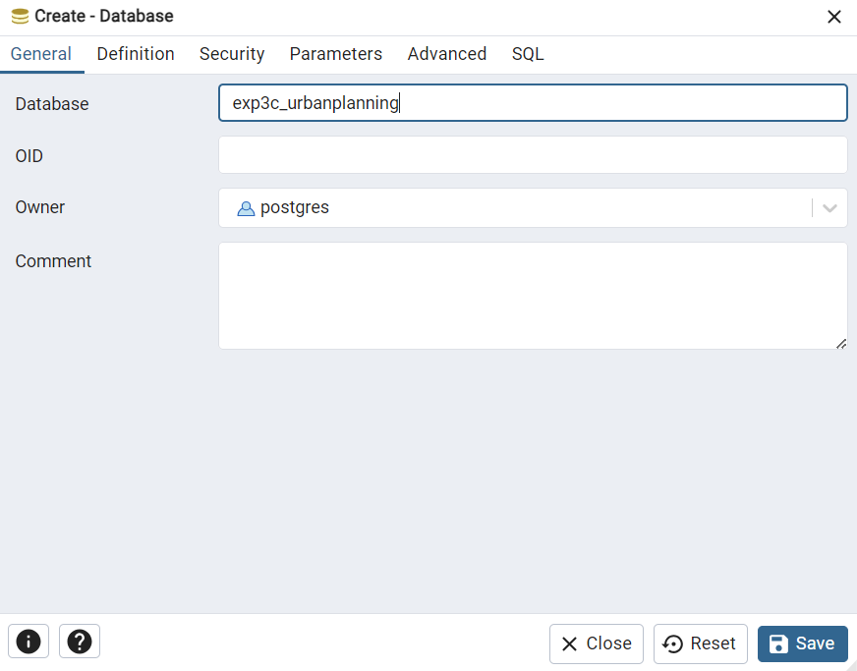

1. *Establish connection.*

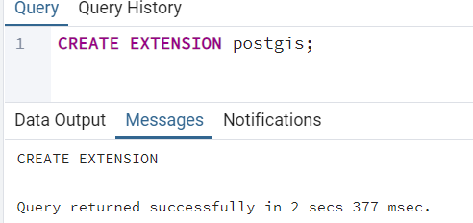

1. *Creating a schema named –* ***urbanplanning*** *and creating the tables under it:* 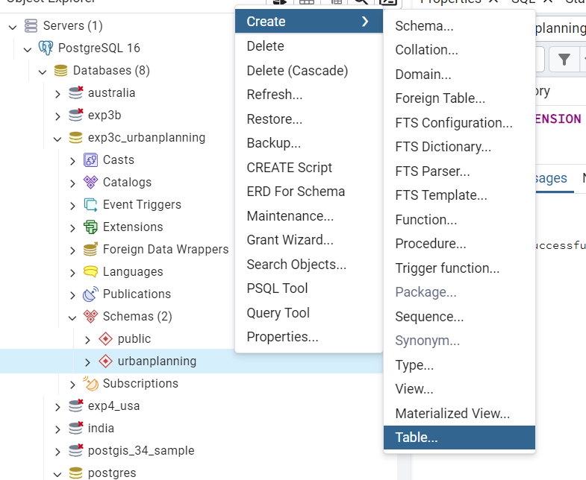

***Implementation:***

1. *Creation of Tables:*
   * + 1. *Buildings:*

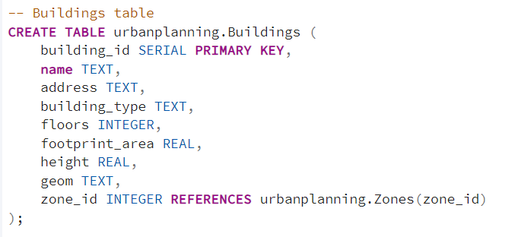

* + - 1. *Zones:*

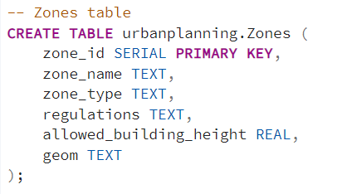

* + - 1. *Roads:*

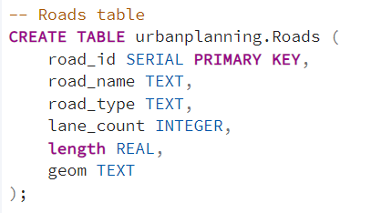

* + - 1. *Public_Facilities:* 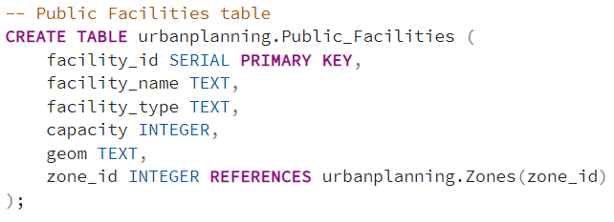
      2. *Land_Parcels:* 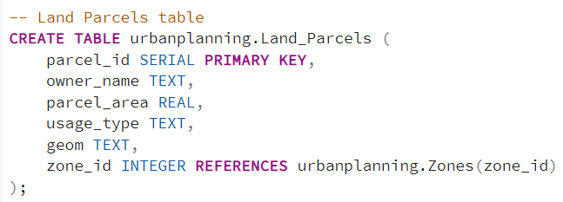

1. *Population of Tables:* 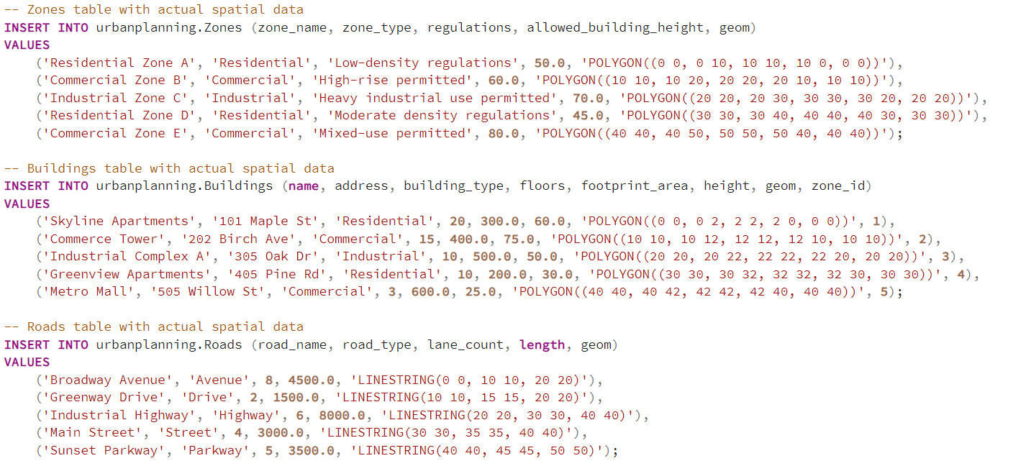 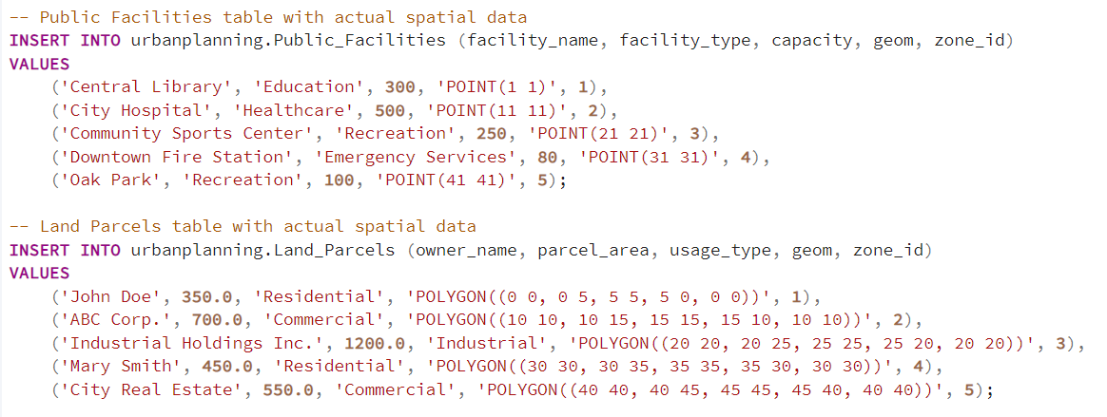 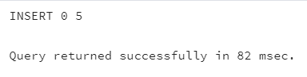

***Execution:***

* 1. *Query for the zones with the least amount of land parcels remaining.*

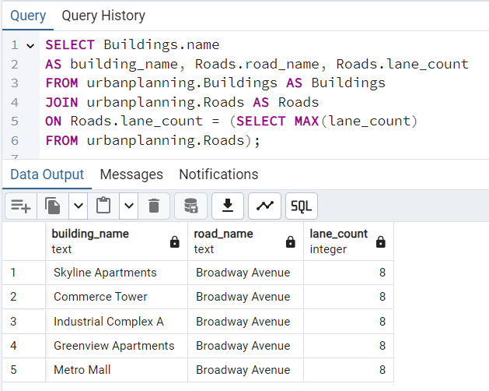

* 1. *Query for the building names near roads with the highest lane count.* 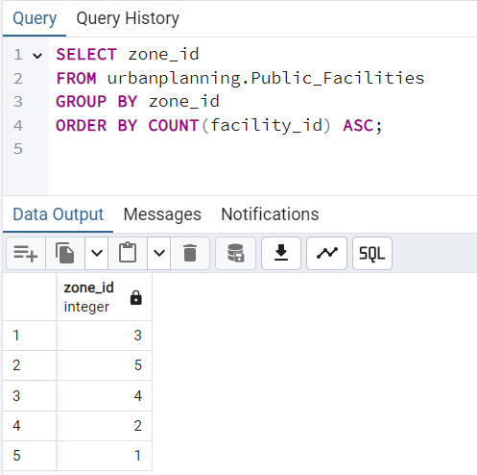
  2. *Query for zone_id with the least number of public facilities:* 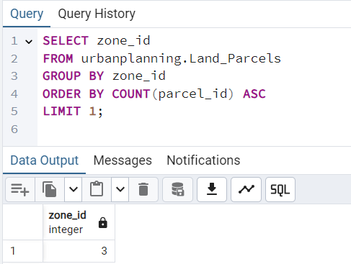

***Conclusion:***

*In conclusion, the urban planning schema presented here provides a robust, data-driven foundation for managing and analyzing various elements critical to city development. By organizing information on zones, buildings, roads, public facilities, and land parcels, the schema enables urban planners to make informed decisions that balance growth, sustainability, and accessibility.*

*This structured approach facilitates efficient zoning compliance, ensures equitable distribution of public resources, and aids in traffic and land use planning. Ultimately, this schema not only helps address current urban needs but also supports scalable planning for future developments, creating more livable, organized, and resilient cities.*